Final Project Report

My Bikes Factory

Submitted to

Teacher: Glauber Torres

By

Student: Varad Sachin Patil (Student ID: 2131419)

Course Number: 420-CT2-AS

Course Title: Object-Oriented Programming Concepts

Session: Winter 2022

Project Description:

In “My Bikes Factory” we were assigned to make a UI which can be operated by the user simply which will allow them to customize their own Bike depending on what type of bike it is, its color, suspension type and the tire type.

Before that a user will have to go through a login form in which if they put in the correct username and password, they’ll have access to the main form where they will be able to customize the bike.

Project Documentation:

The project was divided into 3 main layers:

1. The Business Layer
2. The Data Layer
3. The UI Layer

* The Business Layer: -

This Layer’s responsibility was to provide most of the customization options such as the type of bike the user is trying to build, the color they want to go with, the suspension type they would like the bike to have and the tires of their choice.

But there was a catch in all of it, only a mountain bike would be concerned with the suspension type it has since road bikes don’t rely on it much. Whereas, road bikes highly rely on the tires being used in them. Separate class were made for the stock “Bikes” and “MountainBikes” and “RoadBikes” were a sub class taken from the stock Bikes.

User had its own separate class where the terms, username and password were defined for the first time and were given an initial value.

The “Validator” class that was created is used to validate different inputs that the user puts in the fields such as manufacturing year, the serial number and other things and its helps determining if they’re unique or not.

Enums is the folder in while the classes for the Color, Suspension and Tire type are created so that they’re easily recognizable and changed can be made in the customization option easily if needed.

The Class Diagram is also a part of the Business Layer where you can see how Bikes is the main class and MountainBikes and RoadBikes takes certain info from it being its subclasses.

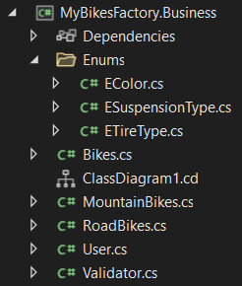

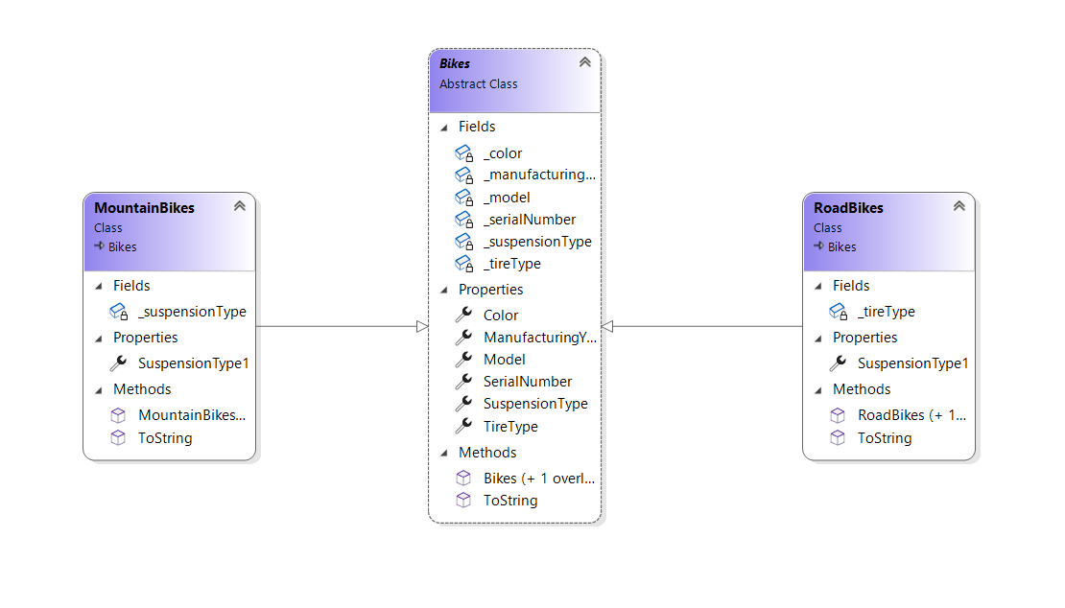

- The Data Layer: -

This Layer is responsible for storing the data of the user and the bikes data which was customized personally by a user.

The User’s data is saved in a sequential manner and so new users can be added any time or changed can be made to previous user’s information while logging in using the login form.

The pre-created user is:

**Username: varad**

**Password: 1234**

But one can always add new user by making changes to the login.txt file.

When a bike is customized and the user saves the customized bike, it’s the job of the class BikesXmlData to save that information saved somewhere so that the form can have access to it any time and it is saved in a serialized manner so that the information is easily accessible.

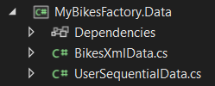

* The UI Layer: -

The UI layer plays a curtail part of binding all the layers together and giving them a visible look so a normal everyday user can make use of this program easily without getting confused in the process.

First we encounter the LoginForm when we run the application which is a windows form where you have to input the valid Username and Password to have access to the MainForm itself.

I decided to make a small change to the stock/normal login form by adding the “show or hide” password button where if a user remembers their password and want to keep their privacy in-check, they can type in their password without it being seen but they can also display it to make sure they entered the correct password.

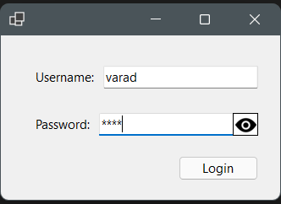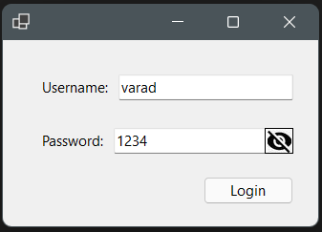

After inputting a valid username and password, MainForm opens up right away where you can see the first option being having to choose a Bike Type.

If you decide to choose a Mountain bike, the category to choose the Tire Type will disappear since it isn’t concerned with it and if you choose a Road bike, Suspension Type category disappears for the same reason.

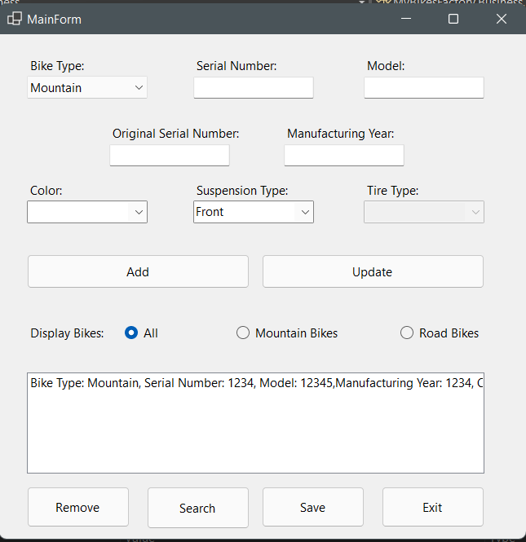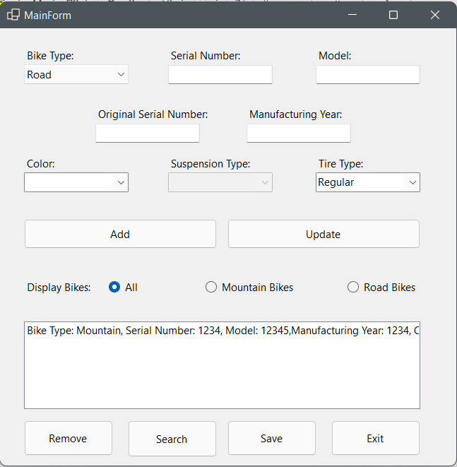

After putting in the valid information for the other categories, if not then the validator class won’t add the bikes that you’ve created, it will be added to the list and will be visible as soon as you hit the Update button which updates the number of bikes customized.

You can further go on saving, searching the bike you customized depending on its serial number which has to be unique or removing a saved bike from the list using the remove button or exiting the application in whole without having to click the “X” button on the top.

Conclusion:

To conclude, working on this application taught me how to separate each class different and systematically so that changes, if needed afterwards can be made easily and that rather than having all the variable definitions in one class, its better to have them in different classes or layers so that one can act as the parent one and it is easy to distribute them.